

Quiz App

**Project Planning Document**

Student Name: Mohammad

**Final Year Project**

# Table of Contents

Table of Contents 2

A. Introduction 3

a. Project Title 3

b. Overview 3

c. Background Literature 3

d. Problem 3

e. Wider Context & General Implication 4

B. Aim & Objectives 4

a. Aim 4

b. Objectives 4

C. Tasks and Deliverables 4

a. Tasks 4

b. Expected Outcomes 5

c. Project Scope 5

d. Project Milestones 5

D. Gantt Chart 6

E. Resources 7

a. Hardware and Software Resources 7

b. Information Sources 7

F. Risks 7

G. Legal, Social, Ethical, and Professional Issues (LSEPI) 8

# Introduction

## Project Title

The title of this Final Year Project (FYP) is Quiz App*.*

## Overview

Keeping one’s knowledge up to date is becoming more of a challenge as each day passes by. There is a need to have a system where one can test one self’s knowledge and have a chance to learn new things, keeping them up to date in their field of interest while enjoying the thrill of competition.

## Background Literature

As the technology grows to facilitate human life, humans have equally dried up their reservoirs of time, in this endless game of chase where technology tries to save time, and humans find ways to use it up even more, the quality of one’s knowledge has gone down. Lesser and lesser people have been visiting the libraries, or acquiring knowledge in any other form.

This creates a paradox of having the need of updated knowledge to make life better, and not having enough time to acquire extra knowledge because time is being consumed in struggle for having a better life. Thus, a need arises to resolve this dilemma, which is what we aim to achieve through this project.

## Problem

The busy human life has undermined the quality of the human life, as the human is less updated on the knowledge; he just struggles endlessly to achieve what he/she yearns for. In an era where it is much difficult to manage time to invest in one’s self; a system must be created to save time and up one’s knowledge game.

## Wider Context & General Implication

The problem of this generation and inherently, of the generations to come, is, it needs to be jack of all trades. This application is therefore not limited to being a quiz application, but it can be used to get a quick study on a topic, substantially reducing the time it would take to read a book or taking a tutorial.

# Aim & Objectives

## Aim

This final year project aims to develop an interactive Android application to test one’s knowledge in favoured field and at the same time, update their knowledge.

## Objectives

This final year project has the following objectives:

* To understand core concepts of chosen topics.
* To research and provide relevant material for questions asked.
* Implement a leader board to motivate for better performance.
* To explore the principles of good UX development for incorporating them in the proposed Android application.

# Tasks and Deliverables

## Tasks

For completing this final year project, the following tasks will be required to be carried out:

* Researching academic material to include in application.
* Designing questions for each field from a chosen list of fields.
* Developing an Android application.
* Testing the Android application for finding possible bugs and addressing them.
* Preparing and submitting a project report containing the details as required by the University.
* Delivering a presentation towards the concluding stage of the project

## Expected Outcomes

This final year project aims to deliver an Android application with questions of varying difficulty in fields; Physics, Chemistry, Maths. And leader board separate for each field.

## Project Scope

The scope of this final year project may be applied to institution level, where they can design their own questions for their courses, and create a leader board locally for the institute against rewards, and thus, create environment of healthy competition.

## Project Milestones

|  |  |  |
| --- | --- | --- |
| **#** | **Project Milestone** | **Deadline** |
| 1 | Project Registration | October 04, 2019 |
| 2 | Review Point 1 & Ethics Declaration | October 24, 2019 |
| 3 | Project Planning Document | November 01, 2019 |
| 4 | Literature Review | November 13, 2019 |
| 5 | Review Point 2 | November 14, 2019 |
| 6 | App Development | February 06, 2020 |
| 7 | App Testing | February 13, 2020 |
| 8 | Review Point 3 & Showcase Entry | February 14, 2020 |
| 9 | Project Report with proofreading | March 18, 2020 |
| 10 | Project Submission | March 20, 2020 |
| 11 | Project Demonstration | April 30, 2020 |

# Gantt Chart

Gantt chart shows the project tasks or milestone with the time it’s going to take. It is used to manage time constrained projects and can be used to calculate time cost of a project. Image below is a Gantt chart made using an online tool: online.officeonline.com

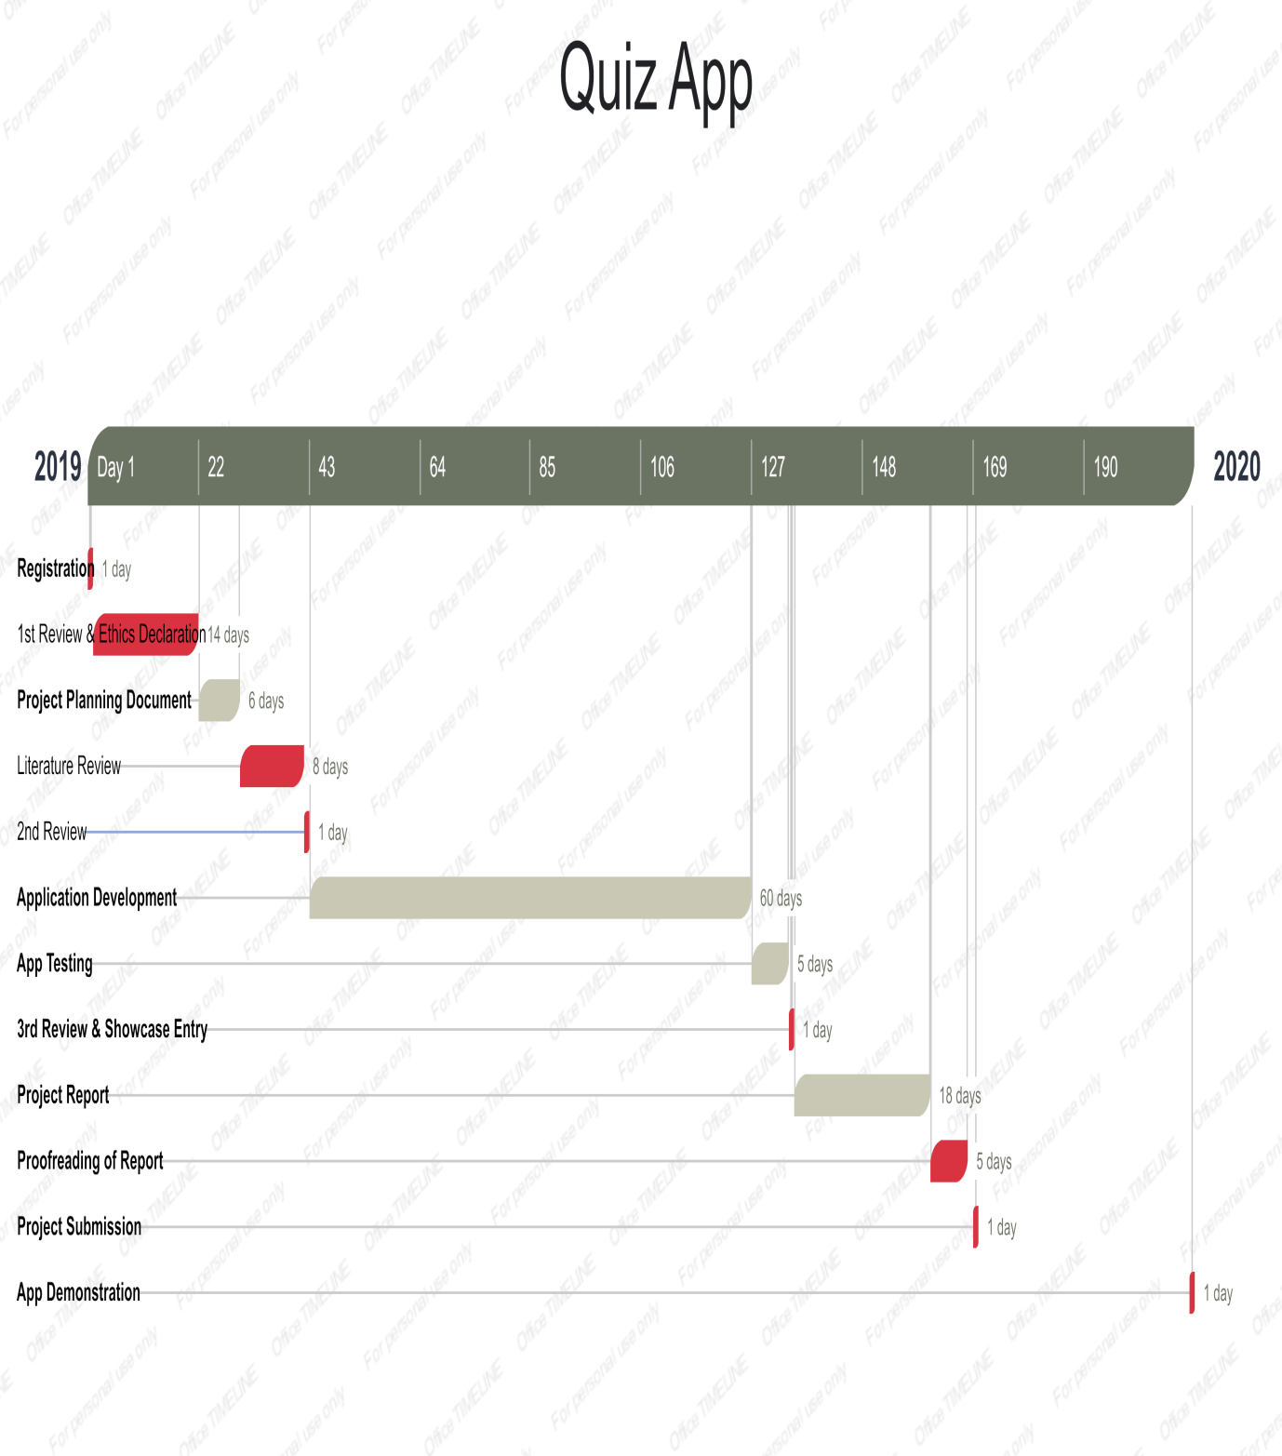

# Resources

## Hardware and Software Resources

Hardware Requirements (minimum):

* System with Windows 7
* 4 GB RAM
* 128 GB Storage
* Phone – Android 7.0
* Quad core
* 2 GB RAM
* 16 GB Storage

Software:

* Unity3D

## Information Sources

Following sources will be used to create this project:

1. Library at Nottingham Trent University
2. Google Scholar & Academia
3. Publicly available tutorials on Unity3D
4. Unity3D official documentation
5. Other trustworthy sources

# Risks

|  |  |  |
| --- | --- | --- |
| Risk | Cause of Risk | Potential Solution |
| Non-completion of project as stated in document | Not enough amount of time put in to work or research taking too much time. | Strictly follow set milestones without any exception. |
| non synchronisation in app features & report | Changes made in the app features and not keeping a track | Keep writing report along with development process |
| App crash | Can be caused due to bugs or device not supporting full features of app | Bugs can be fixed through testing. For full support, a better device is recommended |

# Legal, Social, Ethical, and Professional Issues (LSEPI)

**Legal Issues**:

This app does not promote any illegal activities nor instigate or support such activities. This project complies with all state laws, regarding the IT field and its related laws. It does not violate any user laws, such as data extraction and/or any activity that falls in this category.

**Social Issues**:

This project has no social impact, so there should not be any social issues arising from it either. Other than that, no members of any specific group of society were involved, no questionnaires or surveys were carried out to collect data.

**Ethical Issues**:

There are no features or graphics, residing in this application, that fall in immoral or un-ethical practices. The project will be made following the ethical conduct in the Software Engineering field. If the final report or specification document makes use of any citations; proper references will be provided.

**Professional Issues**:

No organizations or members of professional industry (other than provided by the University) were involved in making of this project. The project is developed originally by the student undertaking this project and thus no copyright claims can be made.